**Vivekanand Education Society’s** 

**Institute of Technology**

**(Affiliated to University of Mumbai, Approved by AICTE & Recognized by Govt. of Maharashtra)**

**Department of Information Technology**

A.Y. 22-23

MAD & PWA Lab

Journal

| Experiment No. | 02 |
| --- | --- |
| Experiment  Title. | To design Flutter UI by including common widgets. |
| Roll No. | 53 |
| Name | SAKSHI SANTOSH PATIL |
| Class | D15B |
| Subject | MAD & PWA Lab |
| Lab Outcome | LO2: Design and Develop interactive Flutter App by using widgets, layouts, gestures and animation |

Grade:

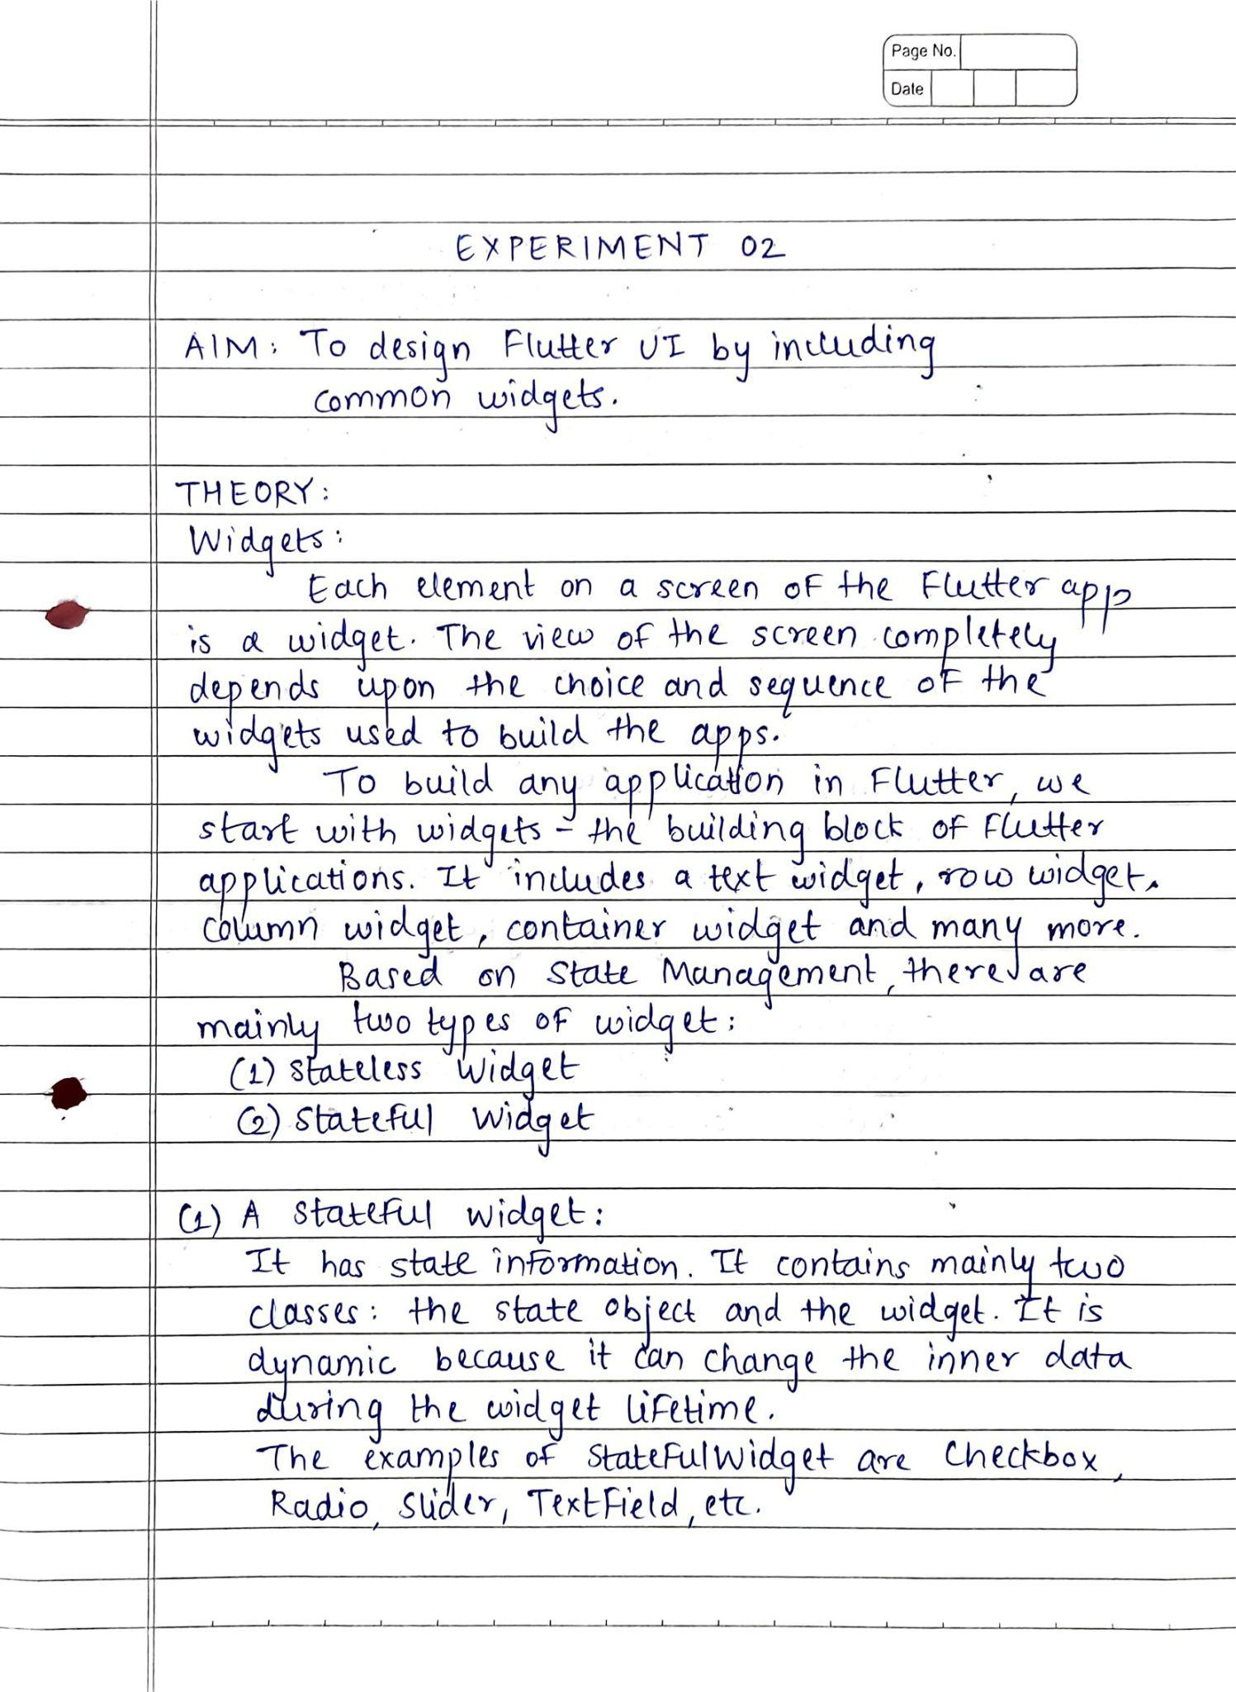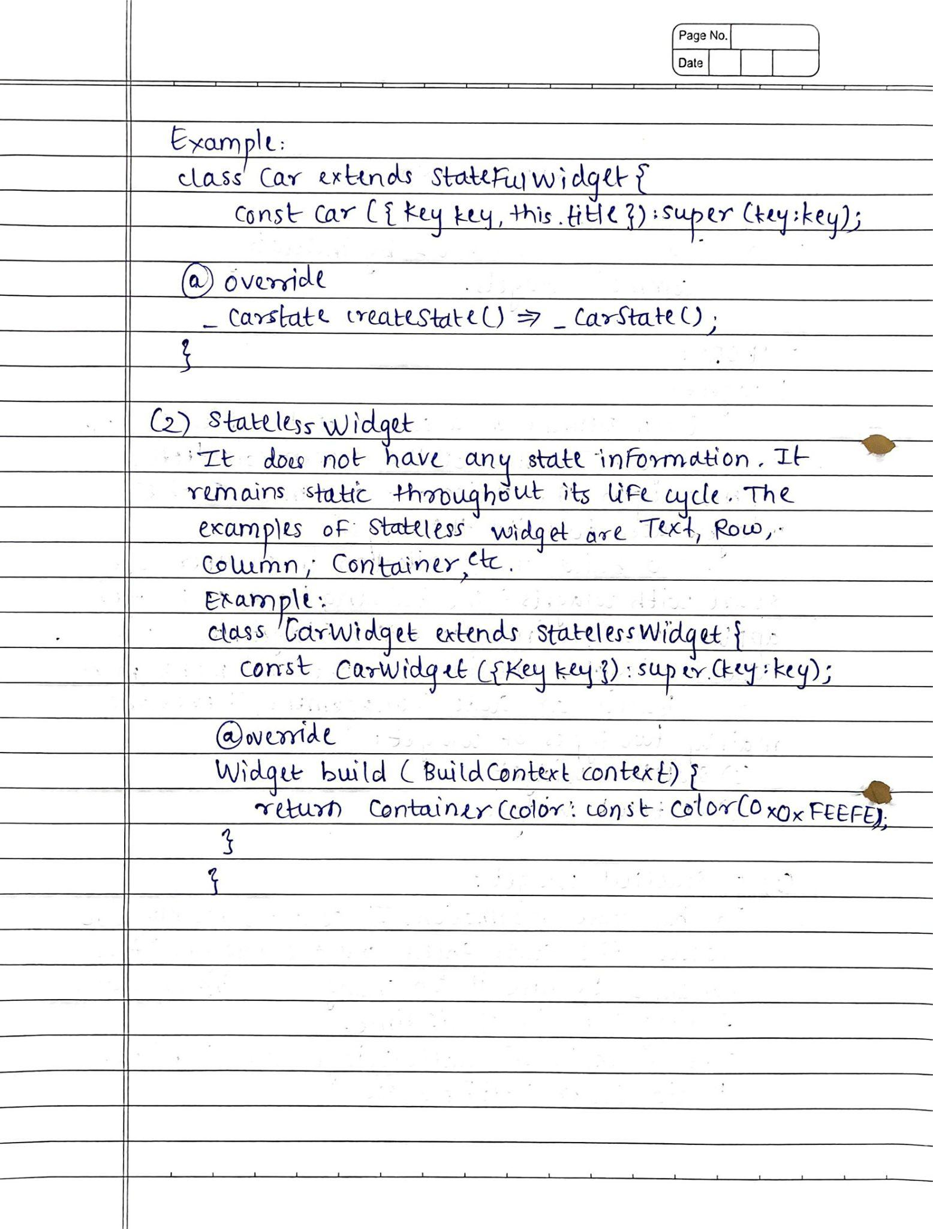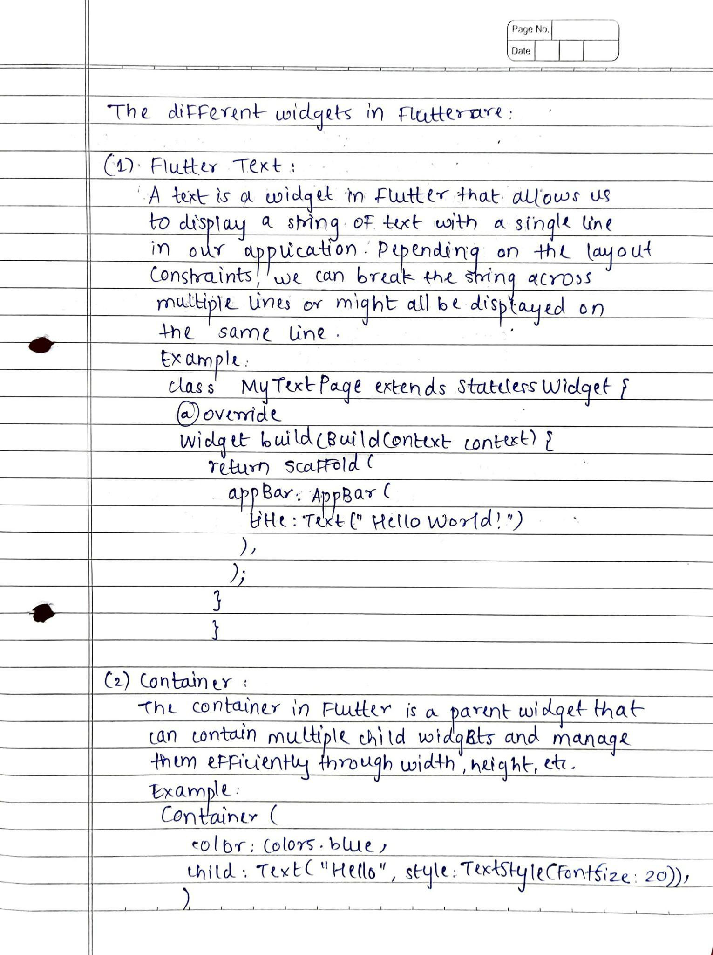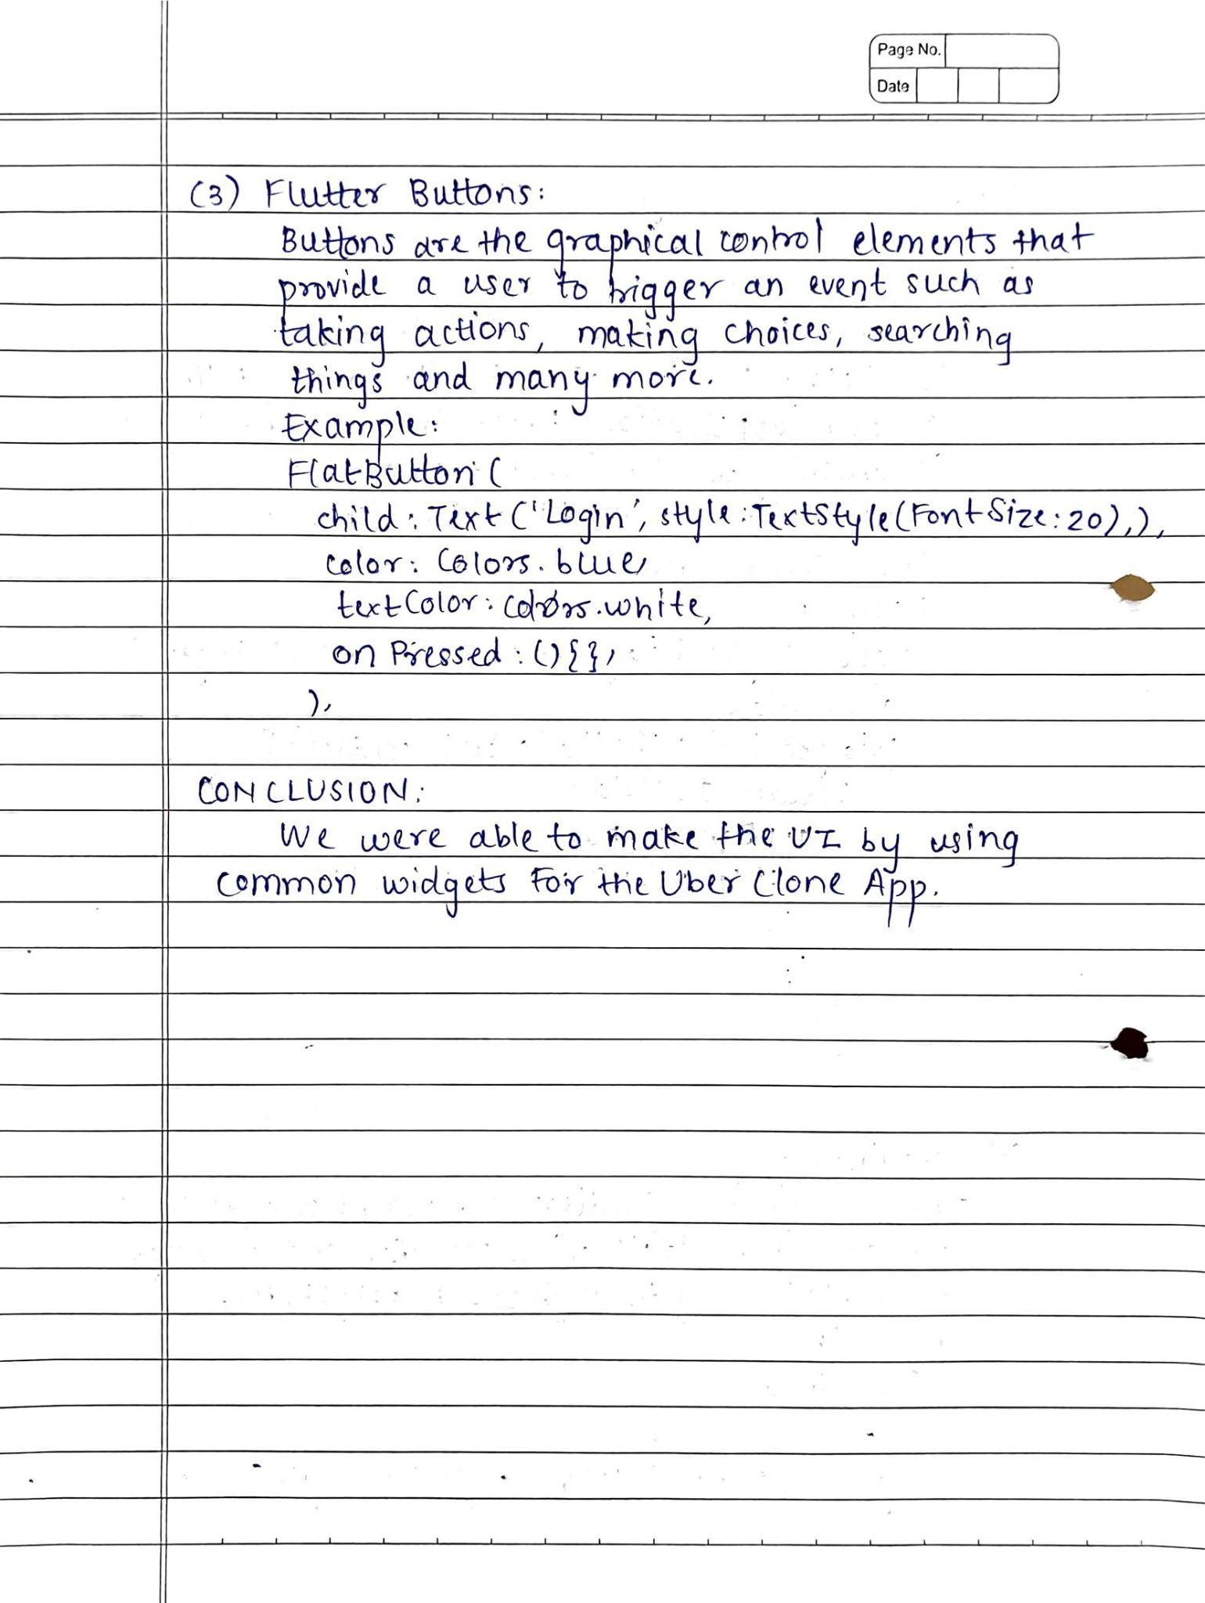

**AIM:** To design Flutter UI by including common widgets

**CODE:**

**main.dart**

import 'package:flutter/material.dart';

import 'package:uber_clone/screens/splashScreen.dart';

void main() {

runApp(const MyApp());

}

class MyApp extends StatelessWidget {

const MyApp({Key? key}) : super(key: key);

@override

Widget build(BuildContext context) {

return MaterialApp(

title: 'Uber',

theme: ThemeData(

fontFamily: "Brand-Bold",

primarySwatch: Colors.*blue*,

visualDensity: VisualDensity.*adaptivePlatformDensity*),

home: SplashScreen(),

debugShowCheckedModeBanner: false,

);

}

}

**SplashScreen.dart**

import 'package:flutter/material.dart';

import 'package:uber_clone/screens/loginScreen.dart';

class SplashScreen extends StatefulWidget {

const SplashScreen({Key? key}) : super(key: key);

@override

State<SplashScreen> createState() => _SplashScreenState();

}

class _SplashScreenState extends State<SplashScreen> {

@override

void initState() {

super.initState();

_navigatetohome();

}

_navigatetohome()async {

await Future.delayed(Duration(seconds: 3), () {});

Navigator.*pushReplacement*(

context, MaterialPageRoute(builder: (context) => loginScreen()));

}

@override

Widget build(BuildContext context) {

return Scaffold(

backgroundColor: Colors.*black*,

body: Container(

child:

Column(

children: [

SizedBox(height: 250.0,),

Image(image: AssetImage("images/Uber-logo-255-150-inverted.jpg"),

height: 210.0,

width: 410.0,

alignment: Alignment.*center*,),

],

),

),

);

}

}

**loginScreen.dart**

import 'package:flutter/material.dart';

import 'package:uber_clone/screens/registrationScreen.dart';

class loginScreen extends StatelessWidget {

const loginScreen({Key? key}) : super(key: key);

static const String *idScreen* ='login';

@override

Widget build(BuildContext context) {

return Scaffold(

resizeToAvoidBottomInset : false,

backgroundColor: Colors.*white*,

body: SingleChildScrollView(

child: Padding(

padding: const EdgeInsets.all(8.0),

child: Column(

children: [

SizedBox(height: 40.0,),

Image(image: AssetImage("images/Uber-logo-255-150.jpg"),

height: 210.0,

width: 410.0,

alignment: Alignment.*center*,),

*// SizedBox(height: 0.0),*

Text(

"Login",

style: TextStyle(fontSize: 26.0, fontFamily: "Brand-Bold"),

textAlign: TextAlign.center,

),

Padding(padding: EdgeInsets.all(45.0),

child: Column(

children: [

*// SizedBox(height: 1.0,),*

TextField(

keyboardType: TextInputType.*emailAddress*,

decoration: InputDecoration(

labelText: "Email",

labelStyle: TextStyle(

fontSize: 14.0,

),

),

style: TextStyle(fontSize: 14.0),

),

SizedBox(height: 1.0,),

TextField(

keyboardType: TextInputType.*emailAddress*,

obscureText:true,

decoration: InputDecoration(

labelText: "Password",

labelStyle: TextStyle(

fontSize: 14.0,

),

),

style: TextStyle(fontSize: 14.0),

),

SizedBox(height: 40.0,),

ElevatedButton(

onPressed: () {

print("lOGIN BUTTON CLICKED");

},

style: ElevatedButton.*styleFrom*(

shape: RoundedRectangleBorder(

borderRadius: BorderRadius.circular(30.0)

),

backgroundColor: Colors.*black*,

),

child: Container(

height: 50.0,

child: Center(

child: Text(

"Login",

style: TextStyle(color:Colors.*white*,fontSize: 18.0,fontFamily: "Brand-Bold"),

),

),

),

)

],

),

),

TextButton(

onPressed: (){},

child: Text(

"Do not have an account? Register here.",

style: TextStyle(color: Colors.*grey*),

)

)

],

),

),

),

);

}

}

**SCREENSHOTS:**

